Edward Welborn

Interfaces and Usability

DEV2318-O

C20190801

Project – Concept assignment

The application that is being put in a concept below is based on a game application. World of Warcraft had an application a few years ago called WoW Armory. In this application you could choose a piece of gear that you had equipped, and it would find a list of suitable upgrades to that gear and tell you how and where to obtain the upgrade.

This application has been discontinued, the new application WoW Companion, does not have this functionality.

Below is a low fi wireframe of 4 screens of the application.

This is the main login screen, the text will be about the program itself, any disclaimers and copyright notices

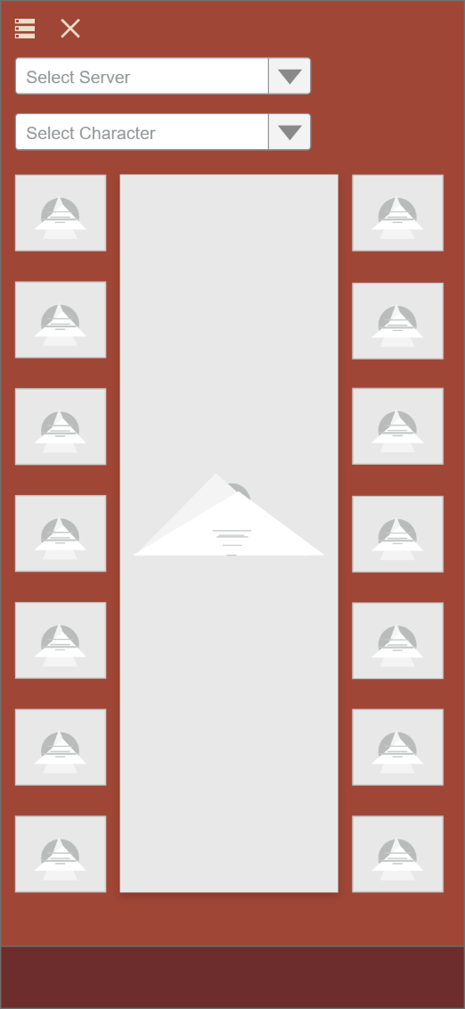

This is the first screen the user will come into contact with after the login. The pictures along the side are the gear slot for each item, i.e. helmet, chest, wrist, etc. The Images along the side will be an image of the item as it looks in game. The center picture is a portrait of the chosen character. The top to dropdown menus are to select the server, as well as select the character once a server is selected. To see the upgrade choices all the user has to do is click a gear picture, it will continue to the next screen.

This is the upgrade list section, at the header will be the slot name, such as helm, chest, arms, etc. The list will populate with available upgrades for that user that they can currently use. The picture will be a picture of the item as it looks in game. Clicking on an item will take the user to the next screen.

This screen is the item detail that the user selected. It will have the item name as the headline, the picture will be of the item as it looks in game. The quote at the bottom will be a description from the game database with backstory, legend of just a description from the game database. The list view on the left will be the stats of the current gear they are wearing in that slot. The list on the left will be what the stats will be when they equip this new item.